DIVISION

TEMPLATES AND GUIDESFG

The Division employs a variety of ABCS that utilize specific ports and protocols. These systems are critical for C2, and as a result visibility of their utilization of the network is also critical. Orion NTA will be configured to account for these systems and their specific traffic types.

1. Access your Orion NTA server.

2. Navigate to the Netflow Tab.

3. Click on NetFlow Settings (upper right).

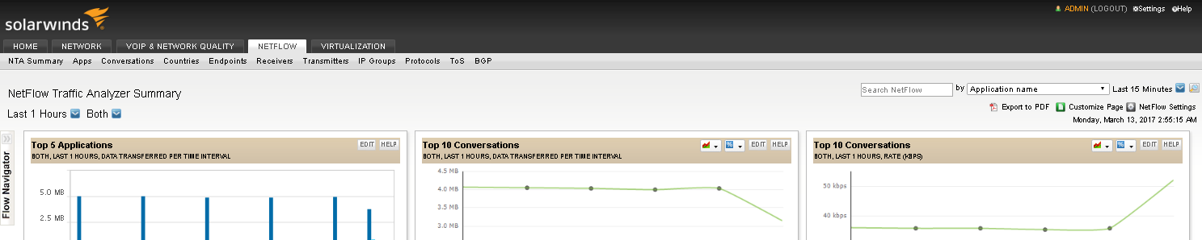

4. Under Netflow Management, click Application and Service Ports.

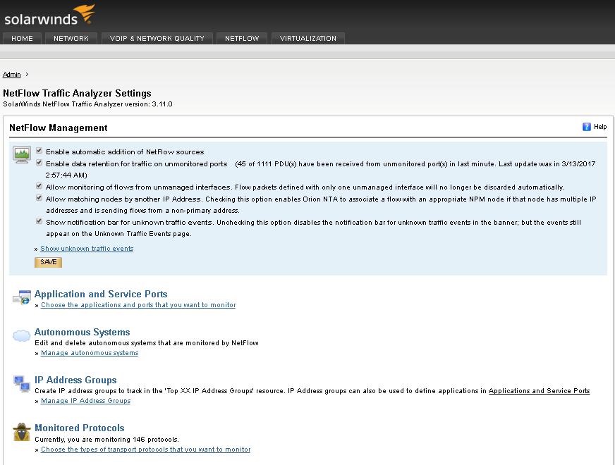

5. Click "Add Application."

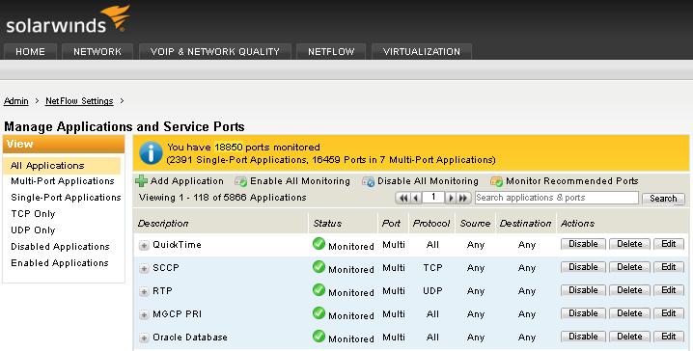

6. A window will appear where you may enter the appropriate information for your application or service.

